**Efficient Timetabling Using Graph Theory Techniques**

**1Ujjwala Kurkute & 2Veena Shinde-Deore**

1 Mithibai College of Arts, Chauhan Institutes of Science & Amrutben Jivanlal College of Commerce and Economics, Vile-Parle, Mumbai, India

2Bhavan’s H. Somani College, Mumbai, India

Email- [ujjwala_kurkute@yahoo.com](mailto:ujjwala_kurkute@yahoo.com), [vinadeore@yahoo.com](mailto:vinadeore@yahoo.com)

***Abstract:***

*Graph Theory is one of the branches of Mathematics where the researchers are attracted due to modeling of daily life situations in graphs and using graphical techniques to find solutions to complex situations. One of the situations the educational institutes always face is the making of timetables for different classes with different subjects.*

*In a school, suppose there are m teachers and n classes, and given that particular teacher is required to teach a particular class for some periods then a complete schedule is to be prepared wherein the minimum possible number of periods are allotted to that teacher. Then allotment of the periods is the timetabling problem. This problem can be presented by a bipartite graph and can be solved by matching and edge-coloring techniques. In this paper, an attempt is made to discuss the timetabling problem with a particular example and an algorithm is presented for the same.*

***Keywords:*** *Bipartite, graph, edge-coloring, Timetabling*

**Introduction:**

The problem is taken from the book ‘Graph Theory with Applications’ by Bondy. J.A. and Murty .U. S. R. (1976). For solving timetabling problems there are different techniques of which coloring of graph theory concept is simple to use and easy to understand.

**The Problem:**

In a school there are m teachers X1,X2,……………,Xm, and n classes Y1,Y2,……………, Yn. Given that teacher Xi is required to teach class Yj for pij periods, schedule a complete timetable in the minimum possible number of periods.

**The Solution:**

The problem can be solved completely using the theory of edge coloring.

Consider a bipartite graph (X, Y), where X={x1,x2,…,xm}, Y={y1,y2,…,yn } and the vertices xi and yj are joined by pij edges.

Each teacher can teach at most one class in any one period. Thus, the assumption is ‘a class can be taught by at most one teacher.’

Hence, the teaching schedule for one period corresponds to a matching in the graph and conversely, each matching corresponds to a possible assignment of teachers to classes for a period.

**Methodology:**

Partition the edges of G into as few matchings as possible, that is to find a number of colors used to color the edges of G such that G is properly colored. The teaching requirement implies that no teacher teaches for maximum p- periods and no class is taught for more than p -periods. Such a timetable is the p-period timetable. It is assumed that only a limited number of classrooms are available.

Consider a p-period timetable in which *l* lessons are given. So, per period, average *l*/p lessons are given. For this, in one of the periods at least { *l*/p } rooms will be needed. Thus in the p-period timetable the *l* lessons can be arranged and this can be done in at most { *l*/p }rooms which are occupied in any one period.

**Lemma:**

Let M and N be disjoint matchings of G with |M| > |N|. Then there are disjoint mappings M' and N' of G such that |M'| = |M|-1,|N'| = |N| + 1 and M' $∪$ N' = M $∪$ N.

**Theorem:**

If G is bipartite and if p ≥ $∆$ (maximum degree of a vertex), then there exists p disjoint matchings M1, M2, …, Mp of G such that E = M1M2…Mp and for

1≤ i ≤ p, [*l*/p] ≤ |Mi| ≤{*l*/p} where *l* is number of lessons.

**Example :**

Suppose that there are four teachers and five classes. The teaching requirement is   
given by matrix P.

|  |  |  |  |  |  |
| --- | --- | --- | --- | --- | --- |
|  | Y1 | Y2 | Y3 | Y4 | Y5 |
| X1 | 2 | 0 | 1 | 1 | 0 |
| X2 | 0 | 1 | 0 | 0 | 1 |
| X3 | 0 | 1 | 1 | 1 | 0 |
| X4 | 0 | 0 | 0 | 1 | 1 |

P = [pij] =

**Four-period timetable**

|  |  |  |  |  |
| --- | --- | --- | --- | --- |
|  | 1 | 2 | 3 | 4 |
| X1 | Y3 | Y1 | Y4 | Y1 |
| X2 | Y2 | - | Y5 | - |
| X3 | Y4 | Y2 | - | Y3 |
| X4 | Y5 | Y4 | - | - |

**Algorithm steps for 4-period timetable:**

1. For teaching requirement matrix P=[pij] , let *l* = ∑ $p_{ij}$, 1≤ i≤ 4 and 1≤ j ≤5.
2. Let ∆ = maximum degree = 4.
3. Construct p-timetable such that,p .
4. Let M1, M2, …, be disjoint matching of timetable graph G.
5. Choose matching $M_{i}$ and $M_{j}$ which differ in size by at most one, $i≠j$.
6. Construct bipartite graph G[$M_{i}∪$. $M_{j}]$.
7. Selecta path of length three that start and end with same matching.
8. By interchanging matching of $M_{i}$ and $M_{j}$ on this selected path , such that

[*l/*p] ≤ |Mi| ≤ {*l*/p}, 1≤ i ≤ p

1. Write revised p-timetable corresponding to new matching $M_{1}^{'}$, $M_{2}^{'}$,…… $M_{p}^{' }$ such that either[*l*/p] or {*l*/p} rooms are occupied in each period .

**Edge colouring for 4-period timetable**

M1 is matching for period -1which is represented using blue color.

M2 is matching for period -2which is represented using black color.

M3 is matching for period -3which is represented using red color.

M4 is matching for period -4which is represented using green color.

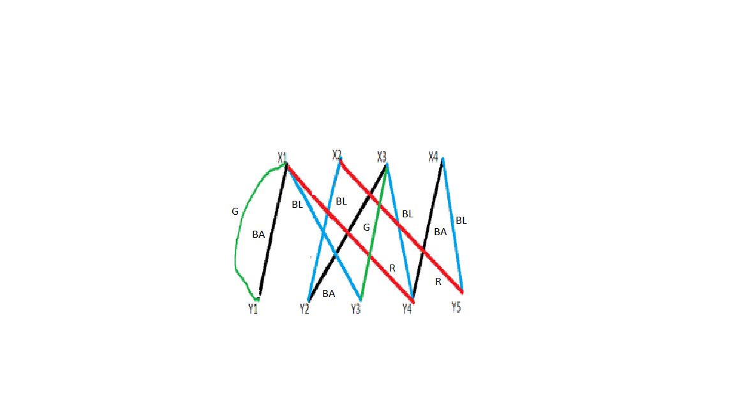

BA: Black, BL: Blue, R: Red, G: Green

Fig 1: Graphical representation of 4-period timetable.

*l* , number of lessons =11.

Using **Theorem 1,** four- period timetable can be arranged in such a way that two(=[11/4]) or three(={11/4}) classes are occupied in each period.

|M1|= 4, |M3|= 2. G[M1M3] is a bipartite graph.

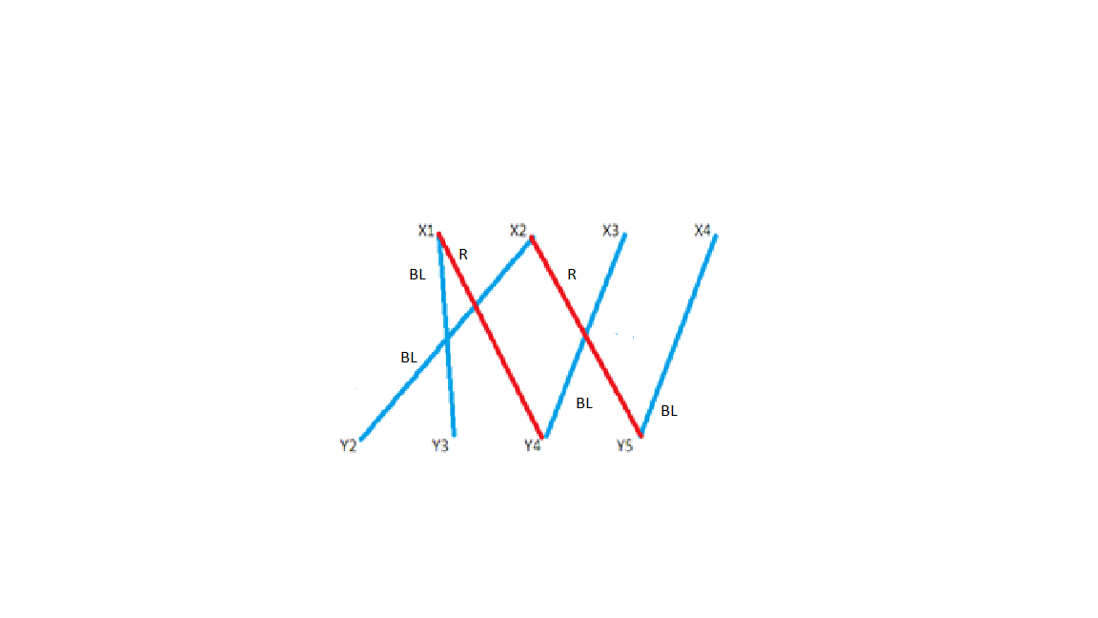

BL: Blue , R: Red

Fig 2: Graphical representation of G[M1M3]

G has two components each consisting of path of length three. Both the path start and end with same matching. Interchange matching on any of the path so as to choose the path Y2 X2Y5X4. Make edges Y2X2, Y5X4 red and X4Y5 blue.

Decompose edge set E as shown in the following fig.

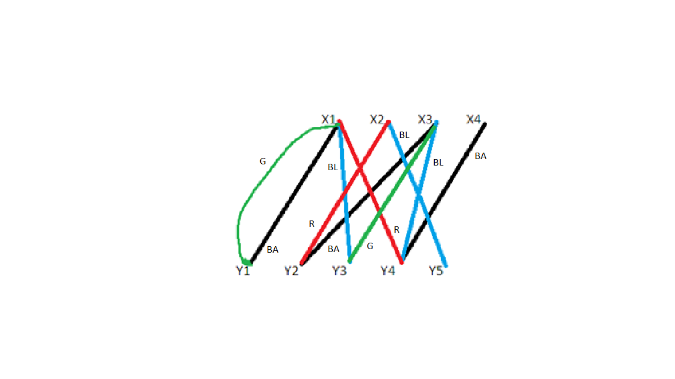

BA: Black , BL: Blue , R: Red , G: Green

Fig 3: Revised graphical representation of 4-period timetable.

So, the revised 4-period timetable is given as follows:

|  |  |  |  |  |
| --- | --- | --- | --- | --- |
|  | 1 | 2 | 3 | 4 |
| X1 | Y3 | Y1 | Y4 | Y1 |
| X2 | Y5 | - | Y2 | - |
| X3 | Y4 | Y2 | - | Y3 |
| X4 | - | Y4 | - | - |

Thus, it can be concluded that a maximum of three rooms is required for any period.

Using **Theorem 1,** five- period timetable can be arranged in such a way that two(=[11/5]) or three(={11/5}) classes are occupied in each period. This can be seen in the following table.

|  |  |  |  |  |  |
| --- | --- | --- | --- | --- | --- |
|  | 1 | 2 | 3 | 4 | 5 |
| X1 | Y3 | Y1 | - | Y1 | Y4 |
| X2 | Y2 | - | - | Y5 | - |
| X3 | Y4 | Y3 | Y2 | - | - |
| X4 | - | - | Y4 | - | Y5 |

Using **Theorem 1,** six-period timetable can be arranged in such a way that two(=[11/6]) and two(={11/5}) classes are occupied in each period. This can be seen in the following table.

|  |  |  |  |  |  |  |
| --- | --- | --- | --- | --- | --- | --- |
|  | 1 | 2 | 3 | 4 | 5 | 6 |
| X1 | Y3 | Y1 | - | Y1 | - | Y4 |
| X2 | Y2 | - | - | Y5 | - | - |
| X3 | - | Y3 | Y2 | - | Y4 | - |
| X4 | - | - | Y4 | - | Y5 | - |

**Result and Analysis**:

One can always arrange *l-*lessons in the p-period timetable so that at most {*l*/p} rooms are available in each period for one day.

**Limitations:**

Due to pre-assignment most of the problems on timetabling are complicated. As all the conditions specify the periods during which certain teachers and classes must meet. This technique becomes complicated if for more than one day is considered to formulate the problem.

**Conclusion:**

The limitations can be overcome if one tries to join different components of the connected graph so as to form a weekly timetable. This generalization of the timetabling problem has been studied by Dempster (1971) and De Werra (1970). Though there are limitations, this concept of forming and solving timetabling problems is not only applicable in academics but also in technical fields like industries.

**References:**

* Bondy, J.A. and Murty, U. S. R. (1976), *‘Graph theory with applications’*, Chapter 6, article 6.3, pp. 96-100.
* Dempster, M. A. H. (1971). Two algorithms for the time-table problem, in *Combinatorial Mathematics and its Applications* (ed. D. J. A. Welsh), Academic Press, New York, pp. 65-85.
* De Werra, D (1970). On some combinatorial problems arising in scheduling. *INFOR*, 8,165-75.
* Gowda, Dr.Dankan & Shashidhara, K.S. & M., Ramesha & S B, & S B, Manoj Kumar. (2021). Recent Advances in Graph Theory and Its Applications. *Advances in Mathematics: Scientific Journal*. 10. 1407-1412. 10.37418/amsj.10.3.29.
* Gupta, R. P. (1966). The chromatic index and the degree of a graph. *Notices Amer. Math. Soc.,* 13, abstract 66T-429.
* Shannon, C. E.(1949). A theorem on coloring the lines of a network. *J. Math. Phys.*, 28,148-51.
* Vizing, V.G. (1964). On an Estimate of the Chromatic Class of A P-Graph(Russian). *Diskret. Analiz*., 3,25-30.